

**PG&E Electric Distribution AM / GIS Project**

|  |
| --- |
| ***WEBR 4.0***  ***Version 0.2*** |

**April 1st, 2015**

Revision History

|  |  |  |  |
| --- | --- | --- | --- |
| **Date** | **Version** | **Description** | **Author(s)** |
| 08/28/14 | 0.1 | Draft | Gareth Thompson |
| 04/1/205 | 0.2 | Updated Requirements | Shaun McCullough |
|  |  |  |  |
|  |  |  |  |

Document Reviewers

|  |  |
| --- | --- |
| **Title** | **Name** |
| GIS Project Managers | Nick Moran PG&E |
| GIS Business Process Team | Robert Smith/Joel Ibarbia PG&E |
| GIS Enterprise Architecture | Vinay Vasa PG&E |
| Senior IT Project Manager | Jose Lemus |

The intended audience includes project leads, functional leads, technical leads, functional staff, and technical staff such as programmers / developers from PG&E and ED GIS Asset Management implementation partners.

# Table of Contents

Table of Contents 3

1 Purpose and Scope 9

1.1 Document Purpose 9

1.2 Document Scope 9

1.3 Requirements Description 9

2 Operating Environments, Software and Versions 10

3 Ventyx Crew Locations 11

3.1 Solution Architecture 11

3.1.1 Solution Description 11

3.1.2 Solution Architecture 12

3.2 Design 13

3.2.1 Description 13

3.2.2 Detailed Configuration & Design 14

3.2.2.1 Database 14

3.3 Sequence Diagrams 18

3.4 Interface Design 18

3.4.1 Web Viewer Map Service 18

3.4.2 Active Directory 19

3.5 Unit Test 19

3.5.1 Test 1: Display Crew Locations 19

3.5.2 Test 2: Update Crew Location Display 20

4 Display Outage Notifications 20

4.1 Solution Architecture 20

4.1.1 Solution Description 20

4.1.2 Solution Architecture 21

4.2 Design 23

4.2.1 Description 23

4.2.2 Detailed Configuration & Design 23

4.2.2.1 Database 23

4.3 Sequence Diagrams 28

4.4 Interface Design 28

4.4.1 Web Viewer Stored Display 28

4.5 Unit Test 30

4.5.1 Test 1: Display Outage Notifications 30

4.5.2 Test 2: Update Outage Notification Display 30

5 Display Outage History Report 30

5.1 Solution Architecture 30

5.1.1 Solution Description 30

5.1.1 Solution Architecture 33

5.2 Design 34

5.2.1 Description 34

5.2.2 Detailed Configuration & Design 34

5.3 Sequence Diagrams 35

5.4 Interface Design 36

5.4.1 Validations 36

5.4.2 Window functionality 37

5.5 Unit Test 37

5.5.1 Test 1: Display Outage History Report 37

5.5.2 Test 2: Display Outage History Report – Error in Properties 37

5.5.3 Test 3: Display Outage History Report – Transformer Not Selected 37

6 Substation Open Point Symbology 38

6.1 Solution Architecture 38

6.1.1 Solution Description 38

6.2 Design 38

6.2.1 Description 38

6.2.2 Detailed Configuration & Design 39

6.3 Sequence Diagrams 40

6.4 Interface Design 40

6.5 Unit Test 40

6.5.1 Test 1: View Sub Fuse – Open position 40

6.5.2 Test 2: View Sub Fuse – Closed position 40

6.5.3 Test 3: View Sub Generator – Open position 40

6.5.4 Test 4: View Sub Generator – Closed position 40

6.5.5 Test 5: View Sub Interrupting Device – Open position 40

6.5.6 Test 6: View Sub Interrupting Device – Closed position 40

6.5.7 Test 7: View Sub Link – Open position 41

6.5.8 Test 8: View Sub Link – Closed position 41

6.5.9 Test 9: View Sub Switch – Open position 41

6.5.10 Test 10: View Sub Switch – Closed position 41

7 SAP Work and Device History 41

7.1 Solution Architecture 41

7.1.1 Solution Description 41

7.1.2 Solution Architecture 42

7.2 Design 44

7.2.1 Description 44

7.2.2 Detailed Configuration & Design 44

7.2.2.1 Web Viewer 44

7.2.2.2 SAP User Interface 44

7.2.2.3 SAP Interface Contract – Request 45

7.2.2.4 SAP Interface Contract – Response 45

7.2.2.5 SAP Interface – Security 46

7.3 Sequence Diagrams 46

7.4 Interface Design 46

7.4.1 Overview Window 46

7.4.1.1 Validations 47

7.4.1.2 Window functionality 47

7.4.2 Detail Window 48

7.4.2.1 Validations 49

7.4.2.2 Window functionality 49

7.5 Unit Test 49

7.5.1 Test 1: SAP Work History display – Device 49

7.5.2 Test 2: SAP Work History display – Structure 49

8 Book Marking 50

8.1 Solution Architecture 50

8.1.1 Solution Description 50

8.2 Design 50

8.2.1 Description 50

8.2.2 Detailed Configuration & Design 51

8.3 Sequence Diagrams 51

8.4 Interface Design 51

8.5 Unit Test 51

8.5.1 Test 1: X 51

8.5.2 Test 2: X 51

9 Silverlight Cache 51

9.1 Solution Architecture 51

9.1.1 Solution Description 51

9.2 Design 52

9.2.1 Description 52

9.2.2 Detailed Configuration & Design 53

9.3 Sequence Diagrams 53

9.4 Interface Design 53

9.5 Unit Test 53

9.5.1 Test 1: X 53

9.5.2 Test 2: X 54

10 Adhoc Printing with Graphics 54

10.1 Solution Architecture 54

10.1.1 Solution Description 54

10.2 Design 54

10.2.1 Description 54

10.2.2 Detailed Configuration & Design 55

10.3 Sequence Diagrams 55

10.4 Interface Design 55

10.5 Unit Test 55

10.5.1 Test 1: X 55

10.5.2 Test 2: X 55

11 Fault Duty/I-BAL data 56

11.1 Solution Architecture 56

11.1.1 Solution Description 56

11.2 Design 56

11.2.1 Description 56

11.2.2 Detailed Configuration & Design 56

11.3 Sequence Diagrams 56

11.4 Interface Design 56

11.5 Unit Test 57

11.5.1 Test 1: X 57

11.5.2 Test 2: X 58

12 Defect : Related Tables 58

12.1 Solution Architecture 58

12.1.1 Solution Description 58

12.2 Design 58

12.2.1 Description 58

12.3 Sequence Diagrams 58

12.4 Interface Design 58

12.5 Unit Test 58

13 Trace Results 59

13.1 Solution Architecture 59

13.1.1 Solution Description 59

13.2 Design 59

13.2.1 Description 59

13.2.2 Detailed Configuration & Design 59

13.3 Sequence Diagrams 59

13.4 Interface Design 59

13.5 Unit Test 62

13.5.1 Test 1: Trace Downstream Device Trace 62

14 Substation Field Properties 62

14.1 Solution Architecture 62

14.1.1 Solution Description 62

14.2 Design 63

14.2.1 Description 63

14.2.2 Detailed Configuration & Design 63

14.3 Sequence Diagrams 63

14.4 Interface Design 63

14.5 Unit Test 63

15 Open Device Display 64

15.1 Solution Architecture 64

15.1.1 Solution Description 64

15.2 Design 64

15.2.1 Description 64

15.2.2 Detailed Configuration & Design 64

15.2.2.1 Map Service 64

15.2.2.2 Symbology 65

15.3 Sequence Diagrams 65

15.4 Interface Design 65

15.5 Unit Test 65

15.5.1 Test 1: Display Open Point symbols 65

16 Requirements out of Scope 65

17 Assumptions and Dependencies 66

18 Appendix A : Display Outage History Report Feasibility 66

19 Appendix B : Sample Outage Data 66

# Purpose and Scope

## Document Purpose

The purpose of this document is to capture the technical design and general configuration for the PG&E Web Viewer (WEBR) application enhancements for release 4.0. Each design section lists the functional and non-functional requirements satisfied by that section. This ensures that the design covers all of the requirements specified for this solution.

## Document Scope

The design document focuses on data design, architectural flow, user interface design and procedural design for the WEBR 4.0 application enhancements. The goal of this document is to communicate intended software design and dependencies of the specific requirement(s) listed above.

## Requirements Description

Schneider WEB Viewer (WEBR) was implemented in the PG&E ESRI environment in Q3 2014. Based on the applications use and the introduction of additional functionality at PG&E a set of enhancement requirements have been gathered. This document shall describe a set of the enhancements for implementation in a new release of WEBR.

This document satisfies the requirements in the WEBR 4.0 Functional Specification as defined in GIS Web Viewer R4 Functional Specification 1.0.docx.

The diagram below shows how the WEBR application fits into the GIS solution architecture.

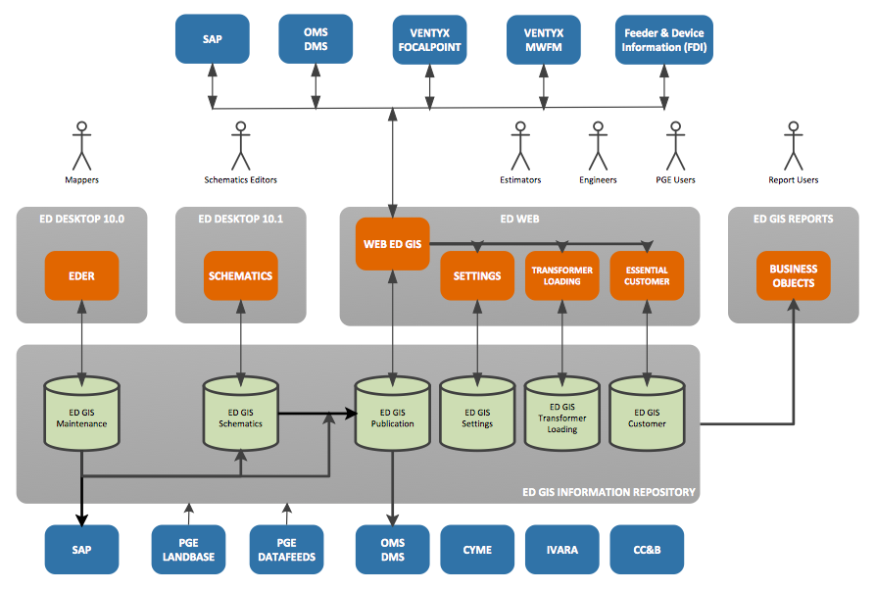

**Figure 1.3-1: To-Be System Context Diagram**

# Operating Environments, Software and Versions

The following section lists the expected physical hardware environment.

Note: There should be no changes from existing versions and infrastructure for the WEBR 4.0 application enhancements.

1. Expected Server Environment
   * Web Server
     + Server OS: Windows Server 2008 Standard R2
     + Application Server: IIS 7.5
     + ASP.Net v4.5 (utilizing C# in the common language runtime)
     + Oracle Client 11.2.0.3 64 bit
   * Database Server
     + Database System: Oracle 11g 64 bit
     + Server OS: AIX 6.1
2. Expected Client Machine Environment
   * Dell Optiplex 790
   * Processor: 3.13 GHz Intel Core i5 2400, 1333MHz FSB, 6MB level 2 cache, 4-Core Processor (Per core SPEC = 31)
   * Memory: 8GB Non-ECC 1333MHz DDR3 SDRAM (2, 4GB SODIMMs, 2 of the 4 slots filled, 16GB max)
   * Chipset: Intel Q65 Express chipset
   * Hard Drive: 250GB SATA 6GB/sec, 7200 RPM, 8MB DataBurst cache
   * Internet Explorer 8.0 or Mozilla Firefox
   * Installed Silverlight Runtime version 5.1 (already available to support the existing Web Viewer application in production).

# Ventyx Crew Locations

## Solution Architecture

### Solution Description

This section details the changes in the WEBR application for displaying Ventyx Crew Locations.

This design section satisfies the following requirements.

| Requirement Number | Requirement Statement | Architectural Component | Requirement Interpretation |
| --- | --- | --- | --- |
| WEB0079 | The solution shall support real time crew location data display. | Crew Map Service | This can only be achieved in ‘near real time’. |
| WEBR4002.1 | The solution will display crew location data as an additional Stored Display in Web Viewer. | Crew Map Service | Interpreted as written |
| WEBR4002.2 | The symbol for a crew location will be a blue truck. | Crew Map Service | Interpreted as written |
| WEBR4002.3 | The solution will support a static display of crew locations that is updated on map refresh, pan, or zoom based on the last time the data was received from the Ventyx system. | Crew Map Service | Interpreted as written |
| WEBR4002.4 | The solution will support printing of the crew locations in the Web Viewer Silverlight printing functionality only. No printing will be available from desktop or Map Production functionality. | Crew Map Service | Interpreted as written |
| WEBR4002.5 | The following attribute information will be available from the crew locations: Tech ID, Timestamp (last time reported in), Lat/Long and Skillset. | Crew Map Service | Interpreted as written |
| WEBR4002.6 | The solution will support searching for Mobile Crew Identifier. | Crew Map Service | Interpreted as written |
| WEBR4003 | The solution will support near real time outage data display. | Crew Map Service | Interpreted as written |
| WEBR4003.1 | The solution will display outage location data as an additional Stored Display in Web Viewer. | Crew Map Service | Interpreted as written |
| WEBR4003.2 | The symbol for an outage notification will be a buffer of around the Primary Conductor based on the following counts of customers out: 1-49 : Green / 50-499 : Light Orange / 500-4999 : Dark Orange and 5000+ : Red | Crew Map Service | Interpreted as written |
| WEBR4003.3 | The solution will support a static display of outage notifications that is updated on map refresh, pan, or zoom based on the last time the data was received from the OMS/DMS system. | Crew Map Service | Interpreted as written |
| WEBR4003.4 | The solution will support printing of the outage notifications in the Web Viewer Silverlight printing functionality only. No printing will be available from desktop or Map Production functionality. | Crew Map Service | Interpreted as written |
| WEBR4003.5 | The following attribute information will be available from the outage notifications: Outage ID, District Number, Feeder Name, Transformer ID, Estimated Repair Time, Outage Start Time, Cause, and Number of Customers Out. | Crew Map Service | Interpreted as written |
| WEBR4003.6 | The solution will support searching for OIS Number. | Crew Map Service | Interpreted as written |
| WEBR4004 | The solution will display transformer outage history (Focal Point). | Crew Map Service | Interpreted as written |
| WEBR4004.1 | The solution will provide the ability to display an outage history report for a transformer. | Crew Map Service | Interpreted as written |
| WEBR4004.2 | The solution will provide the ability to print an outage history report for a transformer. | Crew Map Service | Interpreted as written |
| WEBR4004.3 | The transformer outage history report will display header information including the following: The date on which the report was run, The transformer ID number (CGC #12), The district that the transformer is in, The next source side device upstream from the transformer, The from-date and the to-date that the report covers, and The report title, that is, Transformer Outage History Report. | Crew Map Service | Interpreted as written |
| WEBR4004.4 | The transformer outage history report will display sustained interruptions and a record of momentary interruptions in separate sections with sustained interruptions shown first and momentary interruptions second. | Crew Map Service | Interpreted as written |
| WEBR4004.5 | For sustained interruptions the transformer outage history report will display one row per interruption. | Crew Map Service | Interpreted as written |
| WEBR4004.6 | For sustained interruptions the transformer outage history report will display the following data: Date and Time of the outage, Report Number, Outage Type, Basic Cause, Minutes Out of Service, Open Point Type, Open Point Operating Number and Circuit Number. | Crew Map Service | Interpreted as written |
| WEBR4004.7 | The transformer outage history report will define any outage with duration of greater than 5 minutes as a sustained outage. | Crew Map Service | Interpreted as written |
| WEBR4004.8 | For momentary interruptions the transformer outage history report will display the following data: Date and Time of the outage, Report Number, Outage Type, Basic Cause, Customers affected, Open Point Type, Open Point Operating Number, Open Point Operating Number, and Circuit Number. | Crew Map Service | Interpreted as written |

### Solution Architecture

The diagram below shows the component architecture for the solution with the Crew Location specific components highlighted.

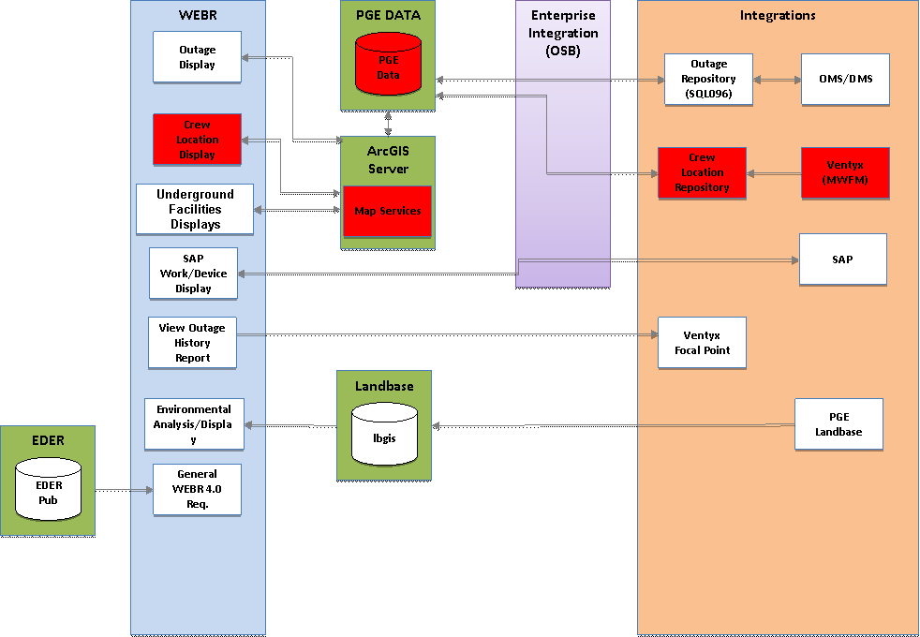

**Figure 3.1.2-1: Crew Location Display Component Diagram**

The Crew Location Display component provides the ability to view Ventyx Crew Locations based on the latest locations in the Ventyx system. The following functionality is required:

1. EI layer pulls the Crew Locations from Ventyx and pushes that latest data into EDGIS via a stored procedure. The stored procedure saves the latest data in a new table in the PGEDATA schema.
2. Web Viewer is configured with an additional stored display map service that displays the crew locations.
3. EDGIS shall have a table for storing the latest pushed crew locations in the PGEDATA schema. No historical data shall be stored, only the latest that was pushed by EI.
4. The display shall not be real-time with updates (i.e. crew locations shall not be updated in the Web Viewer display as the crews move in real-time). The data is only up to date based on the last push if data by EI.
5. The display shall be for electric crews only (not gas).

A corresponding design shall be created by the EI team to define how the data is retrieved and pushed to GIS. This design shall describe the data contract between EI and EDGIS.

## Design

### Description

The diagram below shows the process for retrieving the crew locations from Ventyx and displaying in Web Viewer.

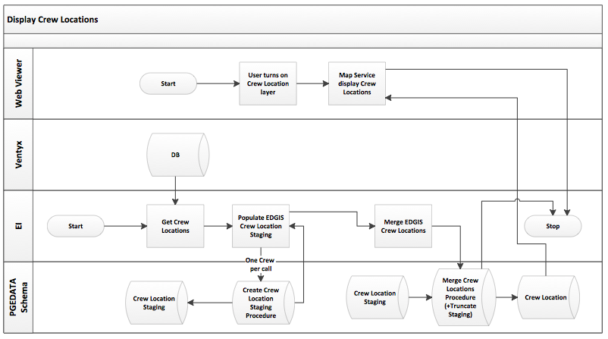

The following limitations are recognized:

1. Crew locations are only available where the crew GPS device is able to transmit its location to the Ventyx system.
2. GPS devices transmit the location every 10 minutes or if the location changes by more than 1 mile. Therefore the crew location information many not always be 100% up to date.
3. Crew locations are refreshed into the Ventyx historic database every 5 minutes. Therefore the crew location information many not always be 100% up to date.

### Detailed Configuration & Design

#### Database

Note: These changes shall not be in publication since they need to be transactional and written to during the day by EI.

##### Tables

###### Crew Location Staging

A new table shall be available in the PGEDATA schema to stage the crew locations.

The table structure is shown in the table below.

|  |  |  |  |
| --- | --- | --- | --- |
| **Name** | PGE_CREW_LOCATION_STG | | |
| **Description** | This table will be populated by EI to stage new crew locations. | | |
| **Column Name** | **Nullable** | **Data Type** | **Description** |
| TECH_ID | No | VARCHAR2 | TECHID of resource from FAS |
| TIMESTAMP | No | DATE | TECH GPS Status Date/time from FAS |
| LAT | No | VARCHAR2 | Latitude from FAS |
| LONG | No | VARCHAR2 | Longitude from FAS |
| SKILLSET | No | VARCHAR2 | Skillset of resource from FAS |

The table shall have the following additional characteristics:

* Primary Key – TECH_ID

###### Crew Location

A new table shall be available in the PGEDATA schema to store the crew locations.

The table structure is shown in the table below.

|  |  |  |  |
| --- | --- | --- | --- |
| **Name** | PGE_CREW_LOCATION | | |
| **Description** | This table will be populated by EI to store crew locations. | | |
| **Column Name** | **Nullable** | **Data Type** | **Description** |
| OBJECT_ID | No | NUMBER | Unique ID of the row |
| TECH_ID | No | VARCHAR2 | TECHID of resource from FAS |
| TIMESTAMP | No | DATE | TECH GPS Status Date/time from FAS |
| SKILLSET | No | VARCHAR2 | Skillset of resource from FAS |
| LOCATION | Yes | SHAPE/ST_GEOMETRY |  |

The table shall have the following additional characteristics:

* Primary Key – OBJECT_ID

##### Stored Procedures

EI will pull the GPS data from FAS every 5 minutes (via scheduled job on UC4) and call the EDGIS stored procedures, which will update the data in EDGIS.

Error Handling:

* EI will log any connection errors and EI support will notify EDGIS support of any error conditions.

###### Create Crew Location Staging

A new stored procedure shall be available in the PGEDATA schema to allow EI to push the crew locations to EDGIS in a staging table.

|  |  |  |  |
| --- | --- | --- | --- |
| **Name** | PGE_CREW_LOCATION_PKG.CREATE_STAGE | | |
| **Description** | This stored procedure will be called by EI to create/update crew locations in the staging table. | | |
| **Parameter Name** | **Required** | **Data Type** | **Description** |
| I_TECH_ID | Yes | VARCHAR2 | TECHID of resource from FAS |
| I_TIMESTAMP | Yes | DATE | TECH GPS Status Date/time from FAS |
| I_LAT | Yes | VARCHAR2 | Latitude from FAS |
| I_LONG | Yes | VARCHAR2 | Longitude from FAS |
| I_SKILLSET | Yes | DOUBLE | Skillset of resource from FAS |
| O_STATUS_CODE |  | NUMBER | 0 for Success, -1 for Failure |
| O_ERROR_MSG |  | VARCHAR2 | Error code associated with the failure |

The PGE_CREW_LOCATION_PKG.CREATE_STAGE procedure shall do the following when called by EI:

1. Determine if a record exists in the PGE_CREW_LOCATION_STG table for I_TECH_ID.
2. If a record exists then update the row values with the following parameter values:
   1. I_TIMESTAMP
   2. I_LAT
   3. I_LONG
   4. I_SKILLSET
3. If no record exists then create a new row with the following parameter values:
   1. I_TECH_ID
   2. I_TIMESTAMP
   3. I_LAT
   4. I_LONG
   5. I_SKILLSET

###### Merge Crew Locations

A new stored procedure shall be available in the PGEDATA schema to allow EI to merge the staged crew locations into the main Crew Locations table.

|  |  |  |  |
| --- | --- | --- | --- |
| **Name** | PGE_CREW_LOCATION_PKG.MERGE_STAGE | | |
| **Description** | This stored procedure will be called by EI to merge the staged crew location table into the main crew location table. | | |
| **Parameter Name** | **Required** | **Data Type** | **Description** |
| O_STATUS_CODE |  | NUMBER | 0 for Success, -1 for Failure |
| O_ERROR_MSG |  | VARCHAR2 | Error code associated with the failure |

The PGE_CREW_LOCATION_PKG.MERGE_STAGE procedure shall do the following when called by EI:

1. For each row in PGE_CREW_LOCATION_STG:
2. Determine if a record exists in the PGE_CREW_LOCATION table for I_TECH_ID.
3. If a record exists then update the PGE_CREW_LOCATION row values with the following values from the STG row:
   1. TIMESTAMP
   2. SKILLSET
   3. LOCATION – set this based on the STG LAT/LONG values.
4. If no record exists then create a new row with the following values from the STG row:
   1. TECH_ID
   2. TIMESTAMP
   3. SKILLSET
   4. LOCATION – set this based on the STG LAT/LONG values.
5. Delete any records from PGE_CREW_LOCATION that are not in PGE_CREW_LOCATION_STG.
6. Truncate the PGE_CREW_LOCATION_STG table.

###### Error Handling

The table below shows errors that may be returned by the stored procedures.

|  |  |  |
| --- | --- | --- |
| **Error Code** | **Error Text** | **Condition** |
| 135 | Error executing SP <Oracle error code, description> | Unhandled exception in the code |

## Sequence Diagrams

See above.

## Interface Design

### Web Viewer Map Service

A new Crew Location map service shall be added to display the following layers:

* Crew Location

Crew Locations shall be made viewable in Web Viewer using the layer control (in a similar way to TLM layers as shown below). Crew Locations shall be grouped with Outage Locations in a “Real Time” map service/layer.

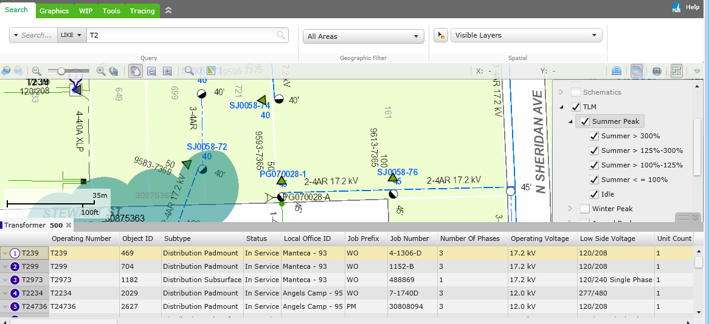

Crew Location data shall be displayed in the Web Viewer as a new map service in the existing Stored Views. The layer shall have the following configuration:

1. By default it shall be turned off.
2. It shall be searchable.
3. Symbol shall be a blue truck.
4. It shall be identifiable and display the following attributes:
   1. Tech ID
   2. Timestamp
   3. Lat/Long
   4. Skillset

### Active Directory

A new Active Directory group/role named “EDGIS_CREW_LOCATION” shall be created.

The Web Viewer shall only allow display of Crew Locations if the current user has the “EDGIS_CREW_LOCATION” group/role.

PG&E IT will need to add the required users to the Active Directory group/role.

## Unit Test

The following test cases are used to validate elements of this design section.

### Test 1: Display Crew Locations

1. Insert crew locations into the PGEDATA schema table (either via EI or manually).
2. Open Web Viewer and turn on the Crew Location layer.
3. Ensure crew locations display as expected.

### Test 2: Update Crew Location Display

1. Refresh (delete existing via stored proc and create new) crew locations into the PGEDATA schema table (either via EI or manually).
2. Open Web Viewer and turn on the Crew Location layer.
3. Ensure crew locations display as expected.

# Display Outage Notifications

## Solution Architecture

### Solution Description

This section details the changes in the WEBR application for display of OMS/DMS Outage notifications.

This design section satisfies the following requirements.

| Requirement Number | Requirement Statement | Architectural Component | Requirement Interpretation |
| --- | --- | --- | --- |
| WEBR4003 | The solution will support near real time outage data display. | Crew Map Service | Interpreted as written |
| WEBR4003.1 | The solution will display outage location data as an additional Stored Display in Web Viewer. | Crew Map Service | Interpreted as written |
| WEBR4003.2 | The symbol for an outage notification will be a buffer of around the Primary Conductor based on the following counts of customers out: 1-49 : Green / 50-499 : Light Orange / 500-4999 : Dark Orange and 5000+ : Red | Crew Map Service | Interpreted as written |
| WEBR4003.3 | The solution will support a static display of outage notifications that is updated on map refresh, pan, or zoom based on the last time the data was received from the OMS/DMS system. | Crew Map Service | Interpreted as written |
| WEBR4003.4 | The solution will support printing of the outage notifications in the Web Viewer Silverlight printing functionality only. No printing will be available from desktop or Map Production functionality. | Crew Map Service | Interpreted as written |
| WEBR4003.5 | The following attribute information will be available from the outage notifications: Outage ID, District Number, Feeder Name, Transformer ID, Estimated Repair Time, Outage Start Time, Cause, and Number of Customers Out. | Crew Map Service | Interpreted as written |
| WEBR4003.6 | The solution will support searching for OIS Number. | Crew Map Service | Interpreted as written |

### Solution Architecture

The diagram below shows the component architecture for the solution with the Outage display specific components highlighted.



**Figure 4.1.2-1: Outage Display Component Diagram**

The Ouatge Display component provides the ability to view Outage Locations based on the latest locations in OMS/DMS. The following functionality is required:

1. EI layer pulls the Outages from the OMS/DMS ‘publication’ database (hosted in SQL Server – SQL096) and pushes that latest data into EDGIS via a stored procedure. The stored procedure saves the latest data in a new table in the PGEDATA schema.
2. Web Viewer is configured with an additional map service that displays the outage locations.
3. EDGIS shall have a table for storing the latest pushed outage locations in the PGEDATA schema. No historical data shall be stored, only the latest that was pushed by EI.
4. The display shall not be real-time with updates (i.e. outage locations shall not be updated in the Web Viewer display as the outages and opened/closed in real-time). The data is only up to date based on the last push if data by EI.

A corresponding design shall be created by the EI team to define how the data is retrieved and pushed to GIS. This design shall describe the data contract between EI and EDGIS.

Appendix B shows an example dataset.

## Design

### Description

The diagram below shows the process for retrieving the outage notifications from OMS/DMS and displaying in Web Viewer.

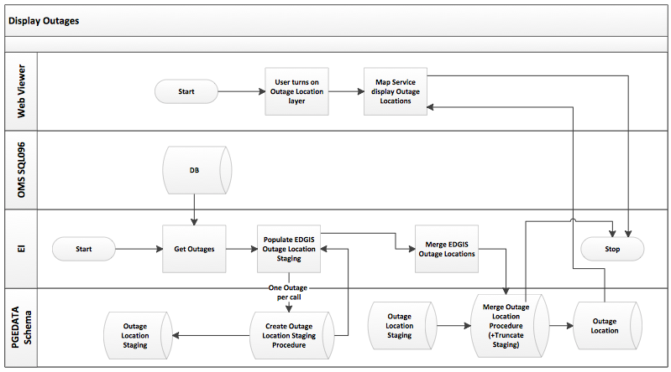

The following limitations are recognized:

1. The outage data is only up to date based on the last time EI pushed the data.

### Detailed Configuration & Design

#### Database

Note: These changes shall not be in publication since they need to be transactional and written to during the day by EI.

##### Tables

###### Outage Location Staging

A new table shall be available in the PGEDATA schema to stage the outage locations.

The table structure is shown in the table below.

|  |  |  |  |
| --- | --- | --- | --- |
| **Name** | PGE_OUTAGE_LOCATION_STG | | |
| **Description** | This table will be populated by EI to stage outage locations. | | |
| **Column Name** | **Nullable** | **Data Type** | **Description** |
| OUTAGE_ID | No | VARCHAR2 | OUTAGEID of resource from OMS/DMS |
| DISTRICT_NO | No | VARCHAR2 | District the outage occurred in |
| FEEDER_NAME | No | VARCHAR2 | Feeder outage occurred on |
| TRANSFORMER_ID | No | VARCHAR2 | Transformer ID of the transformer the outage is on |
| EST_REPAIR_TIME | No | NUMBER | Estimated repair time (in seconds) |
| START_TIME | No | DATE | Date/time outage started |
| CAUSE | No | VARCHAR2 | Cause of outage |
| CREW_STATUS | No | VARCHAR2 | Status of Crew fixing outage |
| CUSTOMERS_OUT | No | NUMBER | Number of customers effected by outage |

The table shall have the following additional characteristics:

* Primary Key – OUTAGE_ID

###### Outage Location

A new table shall be available in the PGEDATA schema to store the outage locations.

The table structure is shown in the table below.

|  |  |  |  |
| --- | --- | --- | --- |
| **Name** | PGE_OUTAGE_LOCATION | | |
| **Description** | This table will be populated by EI to store outage locations. | | |
| **Column Name** | **Nullable** | **Data Type** | **Description** |
| OBJECT_ID | No | NUMBER | Unique ID of the row |
| OUTAGE_ID | No | VARCHAR2 | OUTAGEID of resource from OMS/DMS |
| DISTRICT_NO | No | VARCHAR2 | District the outage occurred in |
| FEEDER_NAME | No | VARCHAR2 | Feeder outage occurred on |
| TRANSFORMER_ID | No | VARCHAR2 | Transformer ID of the transformer the outage is on |
| EST_REPAIR_TIME | No | NUMBER | Estimated repair time (in seconds) |
| START_TIME | No | DATE | Date/time outage started |
| CAUSE | No | VARCHAR2 | Cause of outage |
| CREW_STATUS | No | VARCHAR2 | Status of Crew fixing outage |
| CUSTOMERS_OUT | No | NUMBER | Number of customers effected by outage |
| LOCATION | Yes | SHAPE/ST_GEOMETRY |  |

The table shall have the following additional characteristics:

* Primary Key – OBJECT_ID

##### Stored Procedures

EI will pull the outage data from OMS/DMS every 5 minutes (via scheduled job on Informatica) and call the EDGIS stored procedures, which will update the data in EDGIS.

Error Handling:

* EI will log any connection errors and EI support will notify EDGIS support of any error conditions.

###### Create Outage Location Staging

A new stored procedure shall be available in the PGEDATA schema to allow EI to push the outage locations to EDGIS in a staging table.

|  |  |  |  |
| --- | --- | --- | --- |
| **Name** | PGE_OUTAGE_LOCATION_PKG.CREATE_STAGE | | |
| **Description** | This stored procedure will be called by EI to create/update outage locations in the staging table | | |
| **Parameter Name** | **Required** | **Data Type** | **Description** |
| I_OUTAGE_ID | Yes | VARCHAR2 | OUTAGEID of resource from OMS/DMS |
| I_DISTRICT_NO | Yes | VARCHAR2 | District the outage occurred in |
| I_FEEDER_NAME | Yes | VARCHAR2 | Feeder outage occurred on |
| I_TRANSFORMER_ID | Yes | VARCHAR2 | Transformer ID of the transformer the outage is on |
| I_EST_REPAIR_TIME | Yes | NUMBER | Estimated repair time (in seconds) |
| I_START_TIME | Yes | DATE | Date/time outage started |
| I_CAUSE | Yes | VARCHAR2 | Cause of outage |
| I_CREW_STATUS | Yes | VARCHAR2 | Status of Crew fixing outage |
| I_CUSTOMERS_OUT | Yes | NUMBER | Number of customers effected by outage |
| O_STATUS_CODE |  | NUMBER | 0 for Success, -1 for Failure |
| O_ERROR_MSG |  | VARCHAR2 | Error code associated with the failure |

The PGE_OUTAGE_LOCATION_PKG.CREATE_STAGE procedure shall do the following when called by EI:

1. Determine if a record exists in the PGE_OUTAGE_LOCATION_STG table for I_OUTAGE_ID.
2. If a record exists then update the row values with the following parameter values:
   1. I_DISTRICT_NO
   2. I_FEEDER_NAME
   3. I_TRANSFORMER_ID
   4. I_EST_REPAIR_TIME
   5. I_START_TIME
   6. I_CAUSE
   7. I_CREW_STATUS
   8. I_CUSTOMERS_OUT
3. If no record exists then create a new row with the following parameter values:
   1. I_OUTAGE_ID
   2. I_DISTRICT_NO
   3. I_FEEDER_NAME
   4. I_TRANSFORMER_ID
   5. I_EST_REPAIR_TIME
   6. I_START_TIME
   7. I_CAUSE
   8. I_CREW_STATUS
   9. I_CUSTOMERS_OUT

###### Merge Outage Locations

A new stored procedure shall be available in the PGEDATA schema to allow EI to merge the staged outage locations into the main Outage Locations table.

|  |  |  |  |
| --- | --- | --- | --- |
| **Name** | PGE_OUTAGE_LOCATION_PKG.MERGE_STAGE | | |
| **Description** | This stored procedure will be called by EI to merge the staged outage location table into the main outage location table. | | |
| **Parameter Name** | **Required** | **Data Type** | **Description** |
| O_STATUS_CODE |  | NUMBER | 0 for Success, -1 for Failure |
| O_ERROR_MSG |  | VARCHAR2 | Error code associated with the failure |

The PGE_OUTAGE_LOCATION_PKG.MERGE_STAGE procedure shall do the following when called by EI:

1. For each row in PGE_OUTAGE_LOCATION_STG:
2. Determine if a record exists in the PGE_OUTAGE_LOCATION table for OUTAGE_ID.
3. If a record exists then update the PGE_OUTAGE_LOCATION row values with the following values from the STG row:
   1. DISTRICT_NO
   2. FEEDER_NAME
   3. TRANSFORMER_ID
   4. EST_REPAIR_TIME
   5. START_TIME
   6. CAUSE
   7. CREW_STATUS
   8. CUSTOMERS_OUT
   9. LOCATION – set this based on the location of the EDGIS Transformer feature that matches the TRANSFORMER_ID value.
4. If no record exists then create a new row with the following values from the STG row:
   1. OUTAGE_ID
   2. DISTRICT_NO
   3. FEEDER_NAME
   4. TRANSFORMER_ID
   5. EST_REPAIR_TIME
   6. START_TIME
   7. CAUSE
   8. CREW_STATUS
   9. CUSTOMERS_OUT
   10. LOCATION – set this based on the location of the EDGIS Transformer feature that matches the TRANSFORMER_ID value.
5. Delete any records from PGE_OUTAGE_LOCATION that are not in PGE_OUTAGE_LOCATION_STG.
6. Truncate the PGE_OUTAGE_LOCATION_STG table.

###### Error Handling

The table below shows errors that may be returned by the stored procedures.

|  |  |  |
| --- | --- | --- |
| **Error Code** | **Error Text** | **Condition** |
| 135 | Error executing SP <Oracle error code, description> | Unhandled exception in the code |

## Sequence Diagrams

See above.

## Interface Design

### Web Viewer Stored Display

A new Outage Location map service shall be added to display the following layers:

* Outage
  + 1-49 : Green
  + 50-499 : Light Orange
  + 500-4999 : Dark Orange
  + 5000+ : Red

Outage Locations shall be made viewable in Web Viewer using the layer control (in a similar way to TLM layers as shown below).



Outage Location data shall be displayed in the Web Viewer as a map service in the existing Stored Views. Outage Locations shall be grouped with Crew Locations in a “Real Time” map service/layer.

The layer shall have the following configuration:

1. By default it shall be turned off.
2. It shall be searchable.
3. Symbol shall be a circle colored as follows (based on CUSTOMERS_OUT):
   1. 1-49 : Green
   2. 50-499 : Light Orange
   3. 500-4999 : Dark Orange
   4. 5000+ : Red
4. It shall be identifiable and display the following attributes:
   1. Outage ID
   2. District #
   3. Feeder Name
   4. Transformer ID
   5. Estimated Repair Time
   6. Outage Start Time
   7. Cause
   8. Crew Status
   9. # Customers Out

## Unit Test

The following test cases are used to validate elements of this design section.

### Test 1: Display Outage Notifications

1. Insert outage locations into the PGEDATA schema table (either via EI or manually).
2. Open Web Viewer and turn on the Outage layer.
3. Ensure outage locations display as expected.

### Test 2: Update Outage Notification Display

1. Refresh (delete existing via stored proc and create new) outage locations into the PGEDATA schema table (either via EI or manually).
2. Open Web Viewer and turn on the Outage layer.
3. Ensure outage locations display as expected.

# Display Outage History Report

## Solution Architecture

### Solution Description

This section details the changes in the WEBR application for display of Outage history data from FocalPoint.

This design section satisfies the following requirements.

| Requirement Number | Requirement Statement | Architectural Component | Requirement Interpretation |
| --- | --- | --- | --- |
| WEBR4004 | The solution will display transformer outage history (Focal Point). | Crew Map Service | Interpreted as written |
| WEBR4004.1 | The solution will provide the ability to display an outage history report for a transformer. | Crew Map Service | Interpreted as written |
| WEBR4004.2 | The solution will provide the ability to print an outage history report for a transformer. | Crew Map Service | Interpreted as written |
| WEBR4004.3 | The transformer outage history report will display header information including the following: The date on which the report was run, The transformer ID number (CGC #12), The district that the transformer is in, The next source side device upstream from the transformer, The from-date and the to-date that the report covers, and The report title, that is, Transformer Outage History Report. | Crew Map Service | Interpreted as written |
| WEBR4004.4 | The transformer outage history report will display sustained interruptions and a record of momentary interruptions in separate sections with sustained interruptions shown first and momentary interruptions second. | Crew Map Service | Interpreted as written |
| WEBR4004.5 | For sustained interruptions the transformer outage history report will display one row per interruption. | Crew Map Service | Interpreted as written |
| WEBR4004.6 | For sustained interruptions the transformer outage history report will display the following data: Date and Time of the outage, Report Number, Outage Type, Basic Cause, Minutes Out of Service, Open Point Type, Open Point Operating Number and Circuit Number. | Crew Map Service | Interpreted as written |
| WEBR4004.7 | The transformer outage history report will define any outage with duration of greater than 5 minutes as a sustained outage. | Crew Map Service | Interpreted as written |
| WEBR4004.8 | For momentary interruptions the transformer outage history report will display the following data: Date and Time of the outage, Report Number, Outage Type, Basic Cause, Customers affected, Open Point Type, Open Point Operating Number, Open Point Operating Number, and Circuit Number. | Crew Map Service | Interpreted as written |
| WEBR4004.9 | The transformer outage history report will define an outage with duration of 5 minutes or less as a momentary outage. | Outage Map Service | Interpreted as written  Seconds are not captured, so 6 minutes or less |
| WEBR4004.10 | The solution will make the transformer outage history report available based on selecting a service transformer. | Outage Map Service | Interpreted as written |
| WEBR4004.11 | The solution will provide a dialog for the user to enter the following report parameters: Transformer ID (CGC#12 or Tnum) or Service Point ID, Start Date, and Stop Date. | Outage Map Service | Interpreted as written |
| WEBR4004.12 | For momentary interruptions the transformer outage history report will display one row per interruption. | Outage Map Service | Per Customer outage |
| WEBR4004.13 | The transformer outage history report will be accessible to users through selection of a customer    from a list. | Outage Map Service | Interpreted as written |
| WEBR4004.14 | The transformer outage history solution will use all the outage history data available from the legacy CEDSA database. | Outage Map Service | Interpreted as written |
| WEBR4004.15 | The Outage Reporting and Analysis System Replacement project will convert at least seven years of CEDSA outage history into a data warehouse. | Outage Map Service | Interpreted as written |
| WEBR4004.16 | The data on which the transformer outage history report is based will be updated at least once per business day (Monday - Friday). | Outage Map Service | Interpreted as written |
| WEBR4004.17 | Expected response time for transformer outage history reports is 90% of the reports produced within 2 - 6 seconds with an average of 4 seconds. | Outage Map Service | Interpreted as written |
| WEBR4004.18 | There will be a validation in the Web Viewer to ensure the Start Date is not prior to 2007. | Outage Map Service | Interpreted as written |

### Solution Architecture

The diagram below shows the component architecture for the solution with the Outage history specific components highlighted.

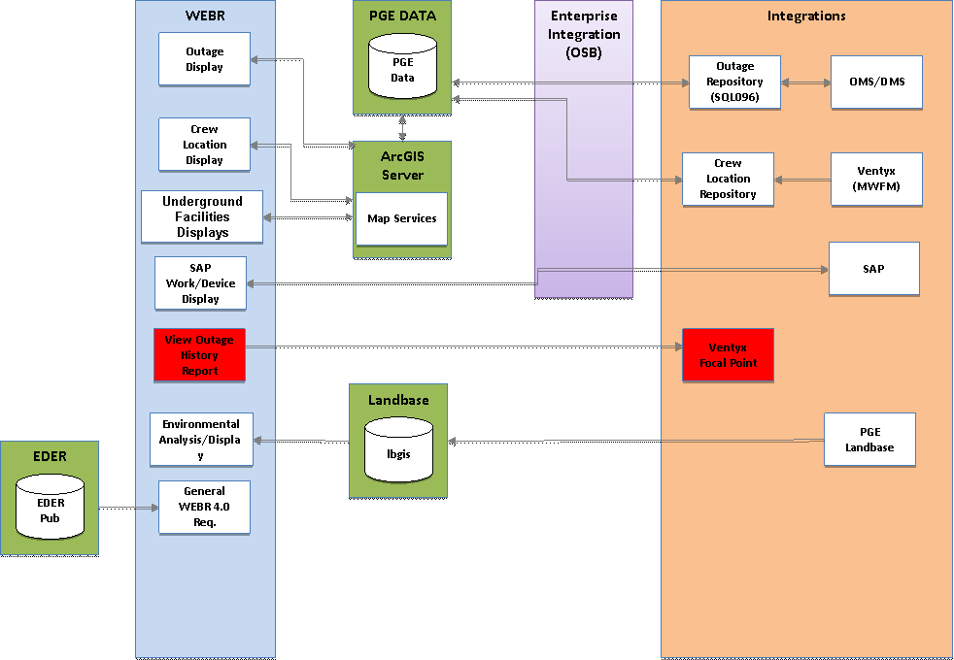

**Figure 5.1.2-1: Outage History Display Component Diagram**

The Ouatge History Display component provides the ability to view Outage history based on a report generated in FocalPoint (launced from Web Viewer). The following functionality is required:

1. Web Viewer shall be enhanced to provide a rollover/right click option for displaying an outage history report.
2. The right click option shall open a new Web Viewer user interface allowing the user to define a start and end date between which outage history shall be displayed.
3. A user can then select a button to display the outage history for the transformer. This shall call an existing report URL in FocalPoint which shall open a new report window (outside of Web Viewer) that displays outage history for the selected transformer.

## Design

### Description

### Detailed Configuration & Design

The following modifications shall be made to Web Viewer:

* New right click option shall be added to the Transformer feature class named “Outage History”.
* New outage history report properties window added to Web Viewer (see Interface Design section).
* Selecting Ok on the outage history report properties window shall gather the transformer CGC, start date, and end date and create a URL in the format shown below. The URL will be started in a new Internet Explorer window.
* Launching the URL will start the report creation in Focal Point. All processing and display of the report is performed in Focal Point. Web Viewer is simply the entry point for defining the transformer, start date, end date, and launching the URL.
* Selecting Cancel on the outage history report properties shall close the window.

The URL for FocalPoint is as follows:

<TBD – to be provide by Grace Ruffner>

The diagram below shows an example FocalPoint report:

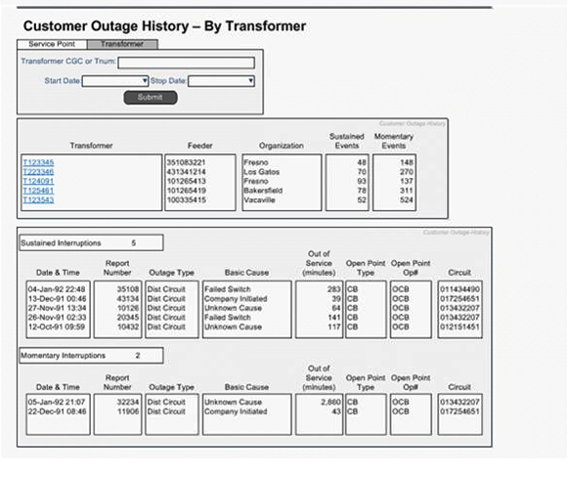

## Sequence Diagrams

The diagram below shows the process for displaying the outage history report.

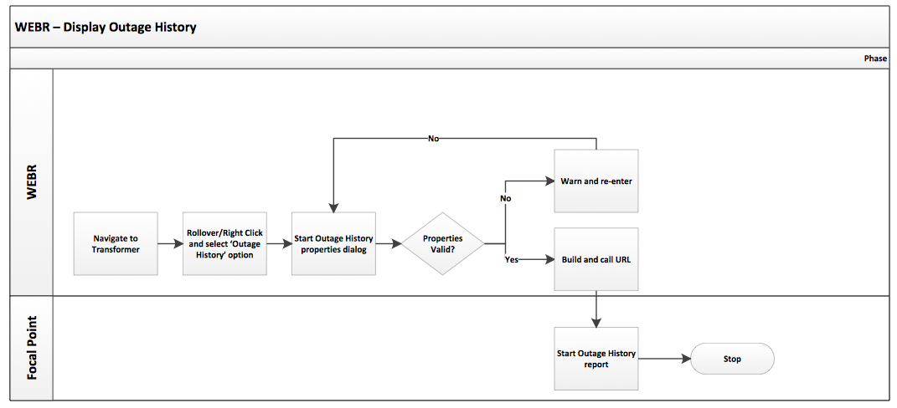

## Interface Design

The following diagram shows the design for the outage history report properties window.

This shall be created using Silverlight.

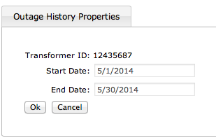

### Validations

The following validations shall be made in the user interface:

* Start Date is a valid date and not earlier than 01/01/2007.
* End Date is a valid date.
* End Date is not prior to the Start Date.

### Window functionality

The style of the window will be aligned with other WEBR Silverlight windows (for example the WIP attributes window).

Errors shall be shown in red below the Ok/Cancel buttons.

Ok builds the Focal Point URL from the property values and then launches the URL (in separate window, not a new tab on the same window).

The new IE window should be an initial default size based on the report from Focal Point.

The new IE window should have the banner title set = “FocalPoint Outage History Report”.

Cancel closed the window.

## Unit Test

The following test cases are used to validate elements of this design section.

### Test 1: Display Outage History Report

1. Navigate to a Transformer in WEBR.
2. Select the right-click option for Outage History.
3. Enter valid start/end dates and select the Ok option.
4. New report should display.

### Test 2: Display Outage History Report – Error in Properties

1. Navigate to a Transformer in WEBR.
2. Select the right-click option for Outage History.
3. Enter invalid start/end dates and select the Ok option.
4. Ensure that an error message is displayed.

### Test 3: Display Outage History Report – Transformer Not Selected

1. Navigate to a Switch in Web Viewer.
2. Ensure that no right click option is available for Outage History.

# Substation Open Point Symbology

## Solution Architecture

### Solution Description

This section details the changes in the Web Viewer application for changes to the symbology for Substation Open Point devices.

This design section satisfies the following requirements.

| Requirement Number | Requirement Statement | Architectural Component | Requirement Interpretation |
| --- | --- | --- | --- |
| WEB0082 | The solution shall display Substation Normal Open Points. | Crew Map Service | Interpreted as written |
| WEBR4075 | The solution will display of all substation open devices in the color Green. | Crew Map Service | Interpreted as written |
| WEB0082.1 | The solution will display Substation devices with a Normal Position (A, B, or C) value = Open with a different symbol to devices where all Normal Position (A, B, and C) values = Closed. | Crew Map Service | Interpreted as written |
| WEB0082.2 | The following Substation devices will display different symbology for switchable status: Sub Fuse, Sub Generator, Sub Interrupting Device, Sub Link and Sub Switch. | Crew Map Service | Interpreted as written |

## Design

### Description

The Substation stored display shall be updated to display devices with symbology based on the normal position values.

The device symbol shall be different depending on the Normal_Position_A, Normal_Postition_B, and Normal_Position_C values. If any of the values = Open the symbol shall be different from a device where all of the values = Closed.

Implementation of the updated symbols requires this change to be available in EDER and inherited by Web Viewer. This involves creating the new symbols, ensuring the ED database is at state 0, and running the AU Conveyor to point the required feature classes to the new symbols.

### Detailed Configuration & Design

The symbology shall be updated in the existing spreadsheet defining substation symbology; SubSymbologyRequirements_100813.xlsx.

In general a green circle around the center of the existing symbol shall be used to denote at least one of the phases has a Normal Position = Open.

The following symbols show prototypes for a subset of the symbols for each of the substation devices.

Sub Fuse

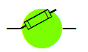

Sub Generator



Sub Interrupting Device

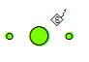

Sub Link



Sub Switch



Note: The green symbology will not print in B&W TIFF files. Since substation internals are not printed in Map Prod 1.0 or 2.0 it is assumed that this is not an issue.

## Sequence Diagrams

Not applicable.

## Interface Design

Not applicable.

## Unit Test

The following test cases are used to validate elements of this design section.

### Test 1: View Sub Fuse – Open position

1. In Web Viewer navigate to a Sub Fuse with a Normal Position A, B, or C = Open
2. Ensure the symbology is as described above.

### Test 2: View Sub Fuse – Closed position

1. In Web Viewer navigate to a Sub Fuse with a Normal Position A, B, and C = Closed
2. Ensure the symbology is as described above.

### Test 3: View Sub Generator – Open position

1. In Web Viewer navigate to a Sub Generator with a Normal Position A, B, or C = Open
2. Ensure the symbology is as described above.

### Test 4: View Sub Generator – Closed position

1. In Web Viewer navigate to a Sub Generator with a Normal Position A, B, and C = Closed
2. Ensure the symbology is as described above.

### Test 5: View Sub Interrupting Device – Open position

1. In Web Viewer navigate to a Sub Interrupting Device with a Normal Position A, B, or C = Open
2. Ensure the symbology is as described above.

### Test 6: View Sub Interrupting Device – Closed position

1. In Web Viewer navigate to a Sub Interrupting Device with a Normal Position A, B, and C = Closed
2. Ensure the symbology is as described above.

### Test 7: View Sub Link – Open position

1. In Web Viewer navigate to a Sub Link with a Normal Position A, B, or C = Open
2. Ensure the symbology is as described above.

### Test 8: View Sub Link – Closed position

1. In Web Viewer navigate to a Sub Link with a Normal Position A, B, and C = Closed
2. Ensure the symbology is as described above.

### Test 9: View Sub Switch – Open position

1. In Web Viewer navigate to a Sub Switch with a Normal Position A, B, or C = Open
2. Ensure the symbology is as described above.

### Test 10: View Sub Switch – Closed position

1. In Web Viewer navigate to a Sub Switch with a Normal Position A, B, and C = Closed
2. Ensure the symbology is as described above.

# SAP Work and Device History

## Solution Architecture

### Solution Description

This section details the changes in the WEBR application for display of SAP work and device history.

This design section satisfies the requirements listed in the solution blueprint and functional:

| Requirement Number | Requirement Statement | Architectural Component | Requirement Interpretation |
| --- | --- | --- | --- |
| WEBR4050.1 | The solution will individually symbolize Patrol (Preventative Inspection), Inspection (Preventative Inspection), DET (Preventative Inspection), Pole Test and Treat (Preventative Inspection), EC tags (Corrective Work), and Planned/PM work (Corrective Work). | SAP Work History |  |
| WEBR4048 | The solution will support linking the SAP Work / Equipment History for all Electric Distribution Facilities. | SAP Work History |  |
| WEBR4048.1 | The solution will support right click display of SAP / Equipment History. | SAP Work History | Interpreted as written |
| WEBR4048.2 | The solution will support cut and paste work order history. | SAP Work History |  |
| WEBR4050.1 | The solution will provide the ability to view the following types of SAP Work and Device history/planned work: Patrol (Preventative Inspection), Inspection (Preventative Inspection), DET (Preventative Inspection), Pole Test and Treat (Preventative Inspection), EC tags (Corrective Work), and Planned/PM work (Corrective Work). | SAP Work History |  |
| WEBR4050.2 | The solution will provide an option to view the SAP Work and Device history/planned work for a device via a rollover and right click option in the map window. | SAP Work History | Interpreted as written |
| WEBR4050.3 | The solution will provide the ability to view the following information for the SAP Work and Device history/planned work for a given device: Type of work, Type of notification, ‘FID’ (Facility, Inspection/Problem, Do/Action), Date of work (creation date if open, closed date if closed), Due Date, Priority and PM Order # (if applicable – relate to also get the MAT, Work Type Code, Major Work Categories, Hours) | SAP Work History | Interpreted as written |
| WEBR4050.4 | The solution will display SAP Work and Device history/planned work for a given device in the following order: Preventative Inspection (Open), Corrective Work (Open), Preventative Inspection (Closed) and Corrective Work (Closed). | SAP Work History | Interpreted as written |
| WEBR4050.5 | The solution will allow SAP Work and Device history/planned work to be exported to Microsoft Excel for all devices: In a user drawn area and In a trace result | SAP Work History | CSV file, Utilizing the attribute and entity order in WEBR |
| WEBR4050.6 | The solution will export SAP Work and Device history/planned work for a set of devices in the following order: Preventative Inspection (Open), Corrective Work (Open), Preventative Inspection (Closed) and Corrective Work (Closed) | SAP Work History |  |
| WEBR4050.7 | The solution will provide the ability to export the following information for the SAP Work and Device history/planned work for a set of devices: Type of work, Type of notification, ‘FID’ (Facility, Inspection/Problem, Do/Action), Date of work (creation date if open, closed date if closed), Due Date, Priority, Location values – addresses, source side device, lat/long and PM Order # (if applicable – relate to also get the MAT, Work Type Code, Major Work Categories, Hours) | SAP Work History |  |
| WEBR4050.8 | The solution will have the ability to view or export SAP Work and Device history/planned work where the information is related to a map/maintenance plat (Patrols and Inspections) and not directly to the device/structure. | SAP Work History |  |
| WEBR4050.9 | The solution will display SAP Work and Device history/planned work for a limited historical period based on the Inspection or Work cycle period. | SAP Work History |  |
| WEBR4050.10 | The solution will have the ability to visualize, for a specific type of work or inspection, on the Web Viewer map window SAP Device planned work against the related devices/structures. | SAP Work History |  |
| WEBR4050.11 | The solution will allow SAP Work and Device history/planned work to be visualized on the Web Viewer map window for all devices: In a user drawn area and In a Trace Result. | SAP Work History | Symbology to be determined during design |
| WEBR4050.12 | The solution will visualize SAP Device planned work on the Web Viewer map according to the work due date as follows: Due Date within the next 6 months, Due Date 6-12 months, and Due Date > 12 months. | SAP Work History | Interpreted as written |
| WEBR4050.13 | The solution will visualize SAP Device planned work on the Web Viewer map according to the work Priority. | SAP Work History |  |

### Solution Architecture

The diagram below shows the component architecture for the solution with the SAP Work/Device History specific components highlighted.



**Figure 7.1.2-1: SAP Work/Device History Display Component Diagram**

The SAP Work/Device History Display component provides the ability to view SAP work and device history associated with a device or structure. The following functionality is required:

1. Web Viewer shall be updated to provide the ability to rollover/right click on a device or structure and display the Device/Work History at that location.
2. This shall provide an option to open a new window to display all of the Preventative and Corrective work at that location that exists in SAP.
3. A new window shall be used to display the information that calls a web service (REST or SOAP to be determined by the SAP team design) hosted in SAP that returns the required data for display.

A corresponding design shall be created by the EI and SAP teams for the web service. This design shall describe the data contract between the systems.

## Design

### Description

The diagram below shows the process for retrieving the SAP work/device history from SAP and displaying in Web Viewer.

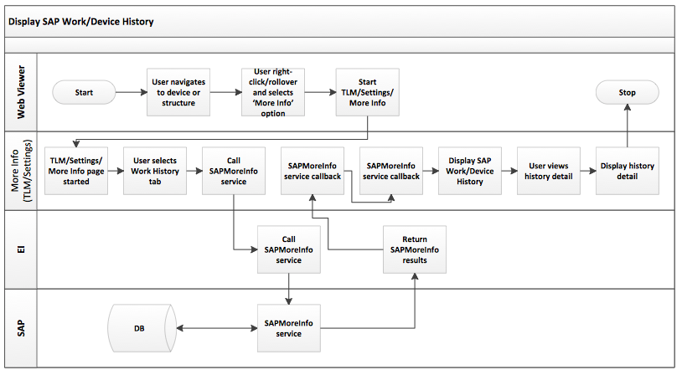

### Detailed Configuration & Design

#### Web Viewer

An option for starting the SAP Work/Device History page shall be added to the rollover/right click option in Web Viewer as well as on the right click in the Attribute Viewer window.

The new options shall call a URL to start the new page with the parameters as defined in section 8.2.2.3.

The following devices and structures shall allow the ‘SAP Work’ option to be enabled:

* All line Devices
* All line Structures

#### SAP User Interface

See later section for description of the interface components.

Prior design pattern used in the Settings and TLM implementations shall be used for the new SAP Device/Work History window using ASP.NET MVC.

#### SAP Interface Contract – Request

The following data elements shall be sent in the SAP web service request:

| **Requirement Number** | **Table/Field from EDGIS** |
| --- | --- |
| Device SAP Equipment ID | <AllTables>.SAPEQUIPID |
| Device Global ID | <AllTables>.GLOBALID |
| Structure SAP Equipment ID | <AllTables>.SAPEQUIPID |
| Structure Global ID | <AllTables>.GLOBALID |
| Maintenance Plat ID | EDGIS.MaintenancePlat.MAPNUMBER |
| Local Office ID | <AllTables>.LOCALOFFICEID |

#### SAP Interface Contract – Response

The following XML data is expected in the SAP web service response:

* Work Category
* Work Type
* Due Date
* Create Date
* Close Date
* Priority
* SAP Notification ID
* SAP Order ID
* <Repeating> Label and Value (***Listed below)

*** The following additional information is anticipated:

‘FID’ (Facility, Inspection/Problem, Do/Action)

PM Order # (if applicable – relate to also get the MAT, Work Type Code, Major Work Categories, Hours)

For example:

<Work>

<WorkItem WorkCategory=”” WorkType=”” DueDate=”” CreateDate=”” CloseDate=”” Priority=”” SAPNotificationID=”” SAPOrderID=””>

<GeneralAttributes>

<Attribute name="PM Order #" value=”" />

< Attribute name="MAT" value="" />

</ GeneralAttributes >

</ WorkItem>

</ Work >

#### SAP Interface – Security

The following service account will be used when calling the SAP Web Service:

SVC_ED_SAPApp_PRD

## Sequence Diagrams

See above.

## Interface Design

### Overview Window

The following diagram shows the design for the SAP Device/Work History overview window. This shall be implemented as a new tab on the TLM and Settings screens. For a device or structure other than the following a ‘More Information’ screen shall be opened with the same look/feel as TLM/Settings:

* Capacitor Bank (and substation equivalent)
* Circuit Breaker
* Interrupter (and substation equivalent)
* Network Protector
* Recloser (and substation equivalent)
* Sectionalizer (and substation equivalent)
* Switch (and substation equivalent)
* Transformer (and substation equivalent)
* Voltage Regulator (and substation equivalent)

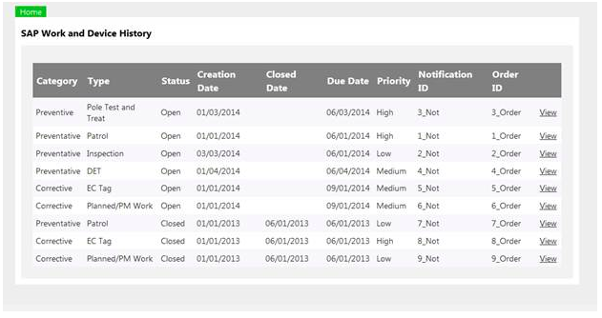

#### Validations

None, data is readonly.

#### Window functionality

This shall be a new tab on existing TLM and Settings screens for the devices shown above. For other devices and structures the style of the window will be aligned with other the Settings and TLM windows.

Selecting the View link on each row will open the Detail window for that row.

The new IE window should be an initial default size.

The new IE window should have the banner title set = “SAP Work and Device History : “ + Device Operating Number or Structure Number.

The list view displays the SAP data in the following order:

* Work Category = Preventative, Status = Open, Due Date (Desc)
* Work Category = Corrective, Status = Open, Due Date (Desc)
* Work Category = Preventative, Status = Closed, Due Date (Desc)
* Work Category = Corrective, Status = Closed, Due Date (Desc)

The window shows the following standard data from the XML:

* Work Category
* Work Type
* Due Date
* Create Date
* Close Date
* Priority
* SAP Notification ID
* SAP Order ID

### Detail Window

The following diagram shows the design for the SAP Device/Work History details window.

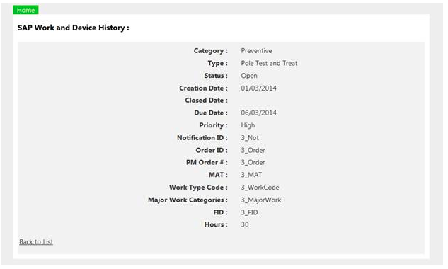

#### Validations

None, data is readonly.

#### Window functionality

The style of the window will be aligned with other the Settings and TLM windows.

The new IE window should be an initial default size.

The new IE window should have the banner title set = “SAP Work and Device History : “ + Device Operating Number or Structure Number.

The window shows the following standard data from the XML:

* Work Category
* Work Type
* Due Date
* Create Date
* Close Date
* Priority
* SAP Notification ID
* SAP Order ID
* All Labels/Values from the <General Attributes> tag

## Unit Test

The following test cases are used to validate elements of this design section.

### Test 1: SAP Work History display – Device

1. Navigate to a Transformer Bank.
2. Rightclick/rollover the Transformer Bank and select the SAP Work option.
3. Ensure the system opens the SAP Overview Window and that data is listed as expected from SAP.
4. Select the View option on one of the rows.
5. Ensure the system opens the SAP Detail Window and that data is listed as expected from SAP.

### Test 2: SAP Work History display – Structure

1. Navigate to a Pole.
2. Rightclick/rollover the Transformer Bank and select the SAP Work option.
3. Ensure the system opens the SAP Overview Window and that data is listed as expected from SAP.
4. Select the View option on one of the rows.
5. Ensure the system opens the SAP Detail Window and that data is listed as expected from SAP.

# Bookmarks / Favorites (inc Silverlight Cache Mgmt)

TODO: are we providing Default functionality? Assuming yes but confirm with Nick.

## Solution Architecture

### Solution Description

This section details the changes in the WEBR application for the Web Viewer Bookmarking enhancement, including Silverlight Cache Management.

This design section satisfies the following requirements:

| Requirement Number | Requirement Statement | Architectural Component | Requirement Interpretation |
| --- | --- | --- | --- |
| WEBR4086 | The solution will support automated clearing of the Silverlight cache without deleting saved user preferences. | Tools and Searching |  |
| WEBR4088 | The solution will support "Bookmarking" GIS data sets and layers to be displayed each time on start-up. | Tools and Searching |  |

## Design

### Description

A user shall be provided an option to save a Private bookmark/display in Web Viewer with the following features:

* Current map view location shall be saved as a bookmark.
* Current visibility of layers in the Stored Displays (all stored displays layers shall be saved) shall be saved as a favorite.
* The user shall be able to name bookmarks and favorites.
* The user shall be able to delete bookmarks and favorites.

An authorized user shall be able to save a Public bookmark/favorite in Web Viewer with the same settings as defined above. These shall be available to all users of Web Viewer.

A user shall be provided with the ability to select a Private bookmark to restore to the current Web Viewer session.

Currently the Silverlight cache is cleared automatically when the Web Viewer version number is changed and opened in a new Internet Explorer window. User preferences for default map location and stored display layer visibility is also stored in the Silverlight cache (as well as any private bookmarks as identified in prior design sections). These user specific items should not be cleared when the Silverlight cache is cleared.

Note: Changes to Stored Displays (adding new layers etc.) mean that private favorites will need to be re-created. A tool will be provided to purge favorites.

### Detailed Configuration & Design

The solution will utilize ArcGIS Server to manage the storage and the REST API to handle communication with the http client.

## Database Changes

New versioned tables will be created in the WIP database WEBR schema.

### PGE_BK_Bookmark featureclass

|  |  |  |  |
| --- | --- | --- | --- |
| **Name** | PGE_BK_BOOKMARK | | |
| **Description** | This table will be populated by EI to stage new crew locations. | | |
| **Column Name** | **Nullable** | **Data Type** | **Description** |
| OBJECTID | No | NUMBER | ArcGIS-managed unique ID |
| EXTENT | No | ST_GEOMETRY | Extent of Area (polygon) |
| NAME | No | VARCHAR2 | Name of the Bookmark |
| DEFAULTYN | No | VARCHAR2 | Should this be the default extent? |
| USER | No | VARCHAR2 | User who owns bookmark |

### PGE_BK_Favorite table

|  |  |  |  |
| --- | --- | --- | --- |
| **Name** | PGE_BK_FAVORITE | | |
| **Description** | This table will be populated by EI to stage new crew locations. | | |
| **Column Name** | **Nullable** | **Data Type** | **Description** |
| OBJECTID | No | NUMBER | ArcGIS-managed unique ID |
| LAYERVISIBILITIES | No | VARCHAR2 | JSON format for Favorite. See below |
| STOREDVIEW | No | VARCHAR2 | Name of the StoredView |
| NAME | No | VARCHAR2 | Name of the Favorite |
| DEFAULTYN | No | VARCHAR2 | Should this be the default extent? |
| USER | No | VARCHAR2 | User who owns favorite |

### LayerVisibilities JSON format

Note that only layers without subLayerIds should be put into the layerIds. If you put groupLayers in then all subLayerIds are shown by default; therefore they should be excluded..

{

LayerVisibilities: [

{“Layer”: “Electric Distribution”,

“VisibleLayerIds”: [

1,

2…

]},

{“Substation”:…

}

]

}

### Administration of Favorites

Favorites will be managed in ArcMap. They will need to be purged after MXD changes where the layer order has changed or new layers are inserted.

## Sequence Diagrams

NA

## Modify Feature Service

### Feature Service: Data/WIPRedlines_Data

Add PGE_BK_Bookmark and PGE_BK_Favorite to the feature service.

## Class Design

The ArcFM Silverlight client will automatically write to the cache – there is no API call to disable it. Therefore, clear the cache every time the application starts up.

All XAML should reside in new folders, Bookmarks / Favorites, in Miner.Server.Silverlight\ArcFMSilverlight\Controls.

Code for the class design should follow MVVM pattern (<https://code.msdn.microsoft.com/silverlight/Design-Patterns-MVVM-Model-d4b512f0>).

The data source for Bookmarks & Favorites will be their Feature Service REST endpoints.

User name comes from WebContext.Current.User.Name

### Bookmark (ViewModel/Model)

The model provides CRUD functionality to the Bookmark feature service.

Use the ArcGIS Silverlight API to access & write to the geodatbase via a FeatureLayer (<https://geonet.esri.com/thread/20536>).

### Favorite (ViewModel/Model)

The model provides CRUD functionality to the Favorite feature service.

## User Interface Design (View)

All dialogs should be modeless (not modal). Use the CADExport.xaml as a template.

All XAML should reside in new folders, Bookmarks / Favorites, in Miner.Server.Silverlight\ArcFMSilverlight\Controls.

### Toolbar buttons

There will be a new toolbar entry in the Tools tab with:

- Create Bookmark

- Manage Bookmarks

- Create Favorite

- Manage Favorites

### Create Bookmark

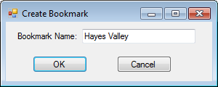

### Manage Bookmarks



### Create Favorite

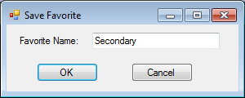

### Manage Favorites

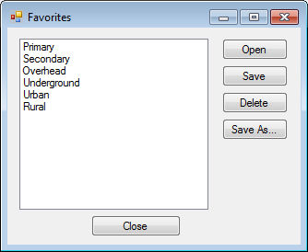

## Unit Test

The following test cases are used to validate elements of this design section. All of the tests for bookmarks apply to favorites, too.

### Retrieve Bookmarks

1. Create 3 Bookmarks
2. Close WEBR and come back in
3. Open Manage Bookmarks

Outcome: The 3 bookmarks from step 1 should be in the Manage Bookmarks window.

### Retrieve 0 Bookmarks

1. Delete any outstanding Bookmarks
2. Close WEBR and come back in
3. Open Manage Bookmarks

Outcome: There should be zero bookmarks.

### Create Bookmark

1. Create Bookmark with name e.g. XXX

Outcome: Bookmark should be created in the geodatabase (use ArcMap and Version Refresh). Verify user/name.

### Create Bookmark with existing name

1. Create bookmark with name “Badgers”
2. Create bookmark with name “Badgers”.

Outcome: You should be prompted to overwrite existing bookmark (Yes/No)

### Create Bookmark with no name

1. Create bookmark and click OK with no name in textbox

Outcome: You should not be able to create a bookmark with no name (OK button should be disabled).

### Create Bookmark with illegal characters

1. Create bookmark and click OK with no name in textbox

Outcome: You should not be able to create a bookmark with illegal characters.

### Open Bookmark

1. Open WEBR at full extent
2. Open Manage Bookmarks
3. Click Zoom To on a bookmark

Outcome: You should be zoomed to the extent of the bookmark.

### Delete Bookmark

1. Open Manage Bookmarks
2. Delete a bookmark

Outcome: Verify the bookmark is removed from the geodatabase

### Save As Bookmark

1. Open Manage Bookmarks
2. Change to a new extent
3. Select bookmark
4. Save a bookmark
5. Close WEBR and come back in
6. Open bookmark from step 3

Outcome: Verify the extent is correct. Verify the bookmark is saved in the geodatabase

### Ensure Silverlight Cache is emptied

1. Open WEBR and change some layer visibility in the TOC
2. Shut down WEBR
3. Open WEBR.

Outcome: Verify that the layer visibility should not be restored from step 1.

#### Feature Service unavailable

1. Stop the FeatureService in ArcGIS Server
2. Open WEBR / Manage Bookmarks

Outcome: User is alerted that the service is down

#### Bookmark not in geodatabase

1. Open Manage Bookmarks
2. Open another WEBR session and delete the bookmark
3. Try to open deleted bookmark

Outcome: User is told Bookmark has been deleted – bookmarks are updated and deleted bookmark is removed from list.

### Favorites

Repeat all steps with Favorites

#### Open saved Favorite

1. Change to Substation Stored View
2. Uncheck Annotation
3. Save Favorite
4. Closer WEBR
5. Reopen and open saved favorite from step 1.

Outcome: Ensure that Stored View is correctly set and that annotation is unchecked..

# Printing and Templates

## Solution Architecture

### Solution Description

This section details the changes in the WEBR application for the Web Viewer Adhoc Printing with Graphics enhancement.

## Design

### Description

The solution shall be update to provide a Print icon/button on the Attribute Viewer accessible from the More/Row Details option as shown below. This shall print the entire contents of the attribute window.

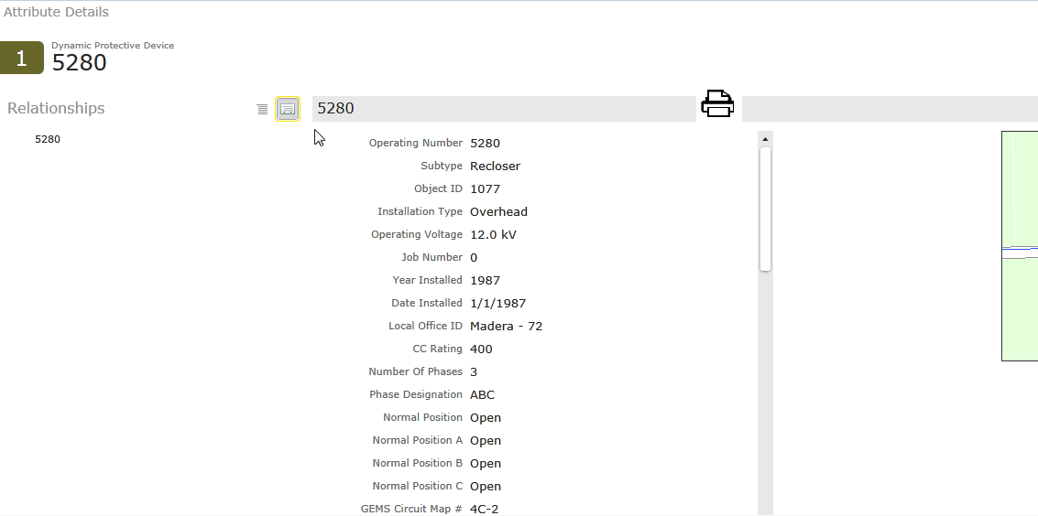

The solution shall be updated so that adhoc printing includes any of the graphics added to the map from the Graphics window. An example of graphics is shown below.

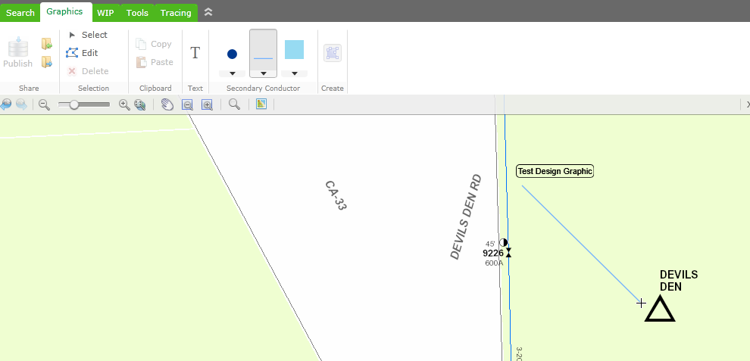

### Detailed Configuration & Design

<Phil Penn to add>

## Sequence Diagrams

NA

## Interface Design

<Phil Penn to add>

## Unit Test

The following test cases are used to validate elements of this design section.

### Test 1: X

1. A:

### Test 2: X

1. B:

# Trace Results

## Solution Architecture

### Solution Description

This section details the changes in the WEBR application for the Trace Results enhancement.

| Requirement Number | Requirement Statement | Architectural Component | Requirement Interpretation |
| --- | --- | --- | --- |
| WEBR4044 | The solution will identify the specific type of dynamic protective device in trace results. | Trace | Interpreted as written |
| WEBR4045 | The solution will display subtype as opposed to Open Points in trace results. | Trace | Trace/ Interpreted as written |
| WEBR4046 | The solution will indicate what devices are SCADA in trace results. | Trace | Interpreted as written |
| WEBR4093 | The solution will display the following on Special Loads:   * Description * Summer KW / Summer KVAR * Winter KW / Winter KVAR * Date Created * Last Modified | Trace |  |
| WEBR4079 | The solution will support traverse geo-network tracing, tracing by adjacent vault, tracing from one vault to another based on filter selection. | UFM Tracing | Interpreted as written |
| WEBR4080 | The solution will display conduit trace results in the order of connectivity. | UFM Tracing | Ordering is correct only for contiguous conduit. |
| WEBR4090 | The solution will support selection of conductor and the display of the vaults that the conductor passes through. | UFM Tracing | Interpreted as written |
| WEBR4091 | The solution will have the ability for a user to select a conductor and identify all the vaults that the selected conductor runs through. | UFM Tracing | UFM Trace |

## Design

### Description

### Detailed Configuration & Design

See interface design.

## Sequence Diagrams

NA

## Interface Design

The existing Web Viewer trace interface shall add a hover over window that displays additional, configurable, information for the feature. The interface is shown below.

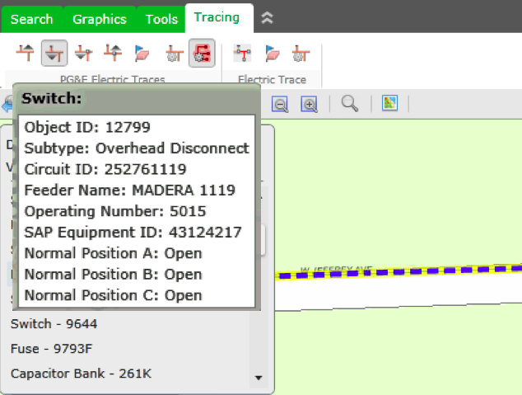

The following additional attribution shall be displayed:

* Dynamic Protective Device – SubtypeCD

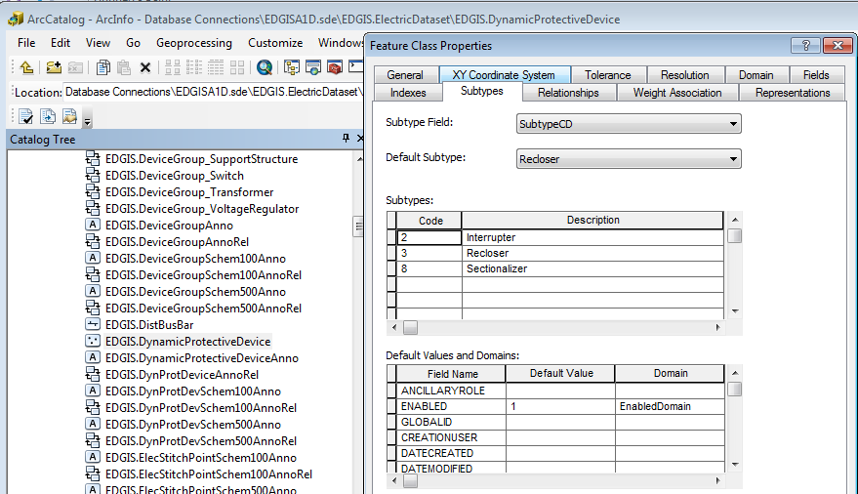

* Open Point – SubTypeCD

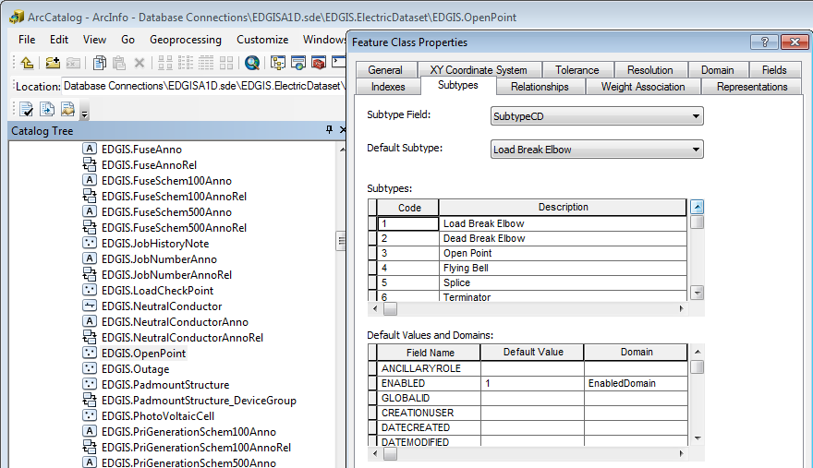

* Capacitor Bank, Dynamic Protective Device, Switch, Voltage Regulator with an associated SCADA record.

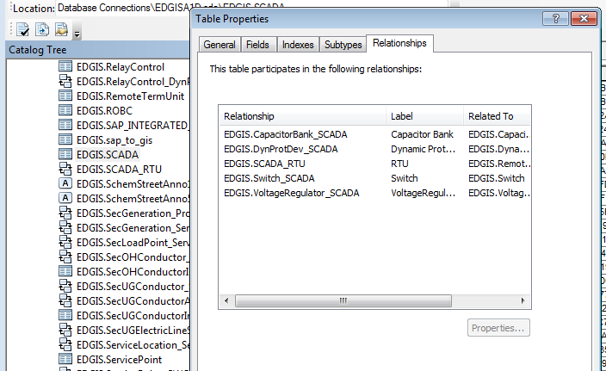

## Unit Test

The following test cases are used to validate elements of this design section.

### Test 1: Trace Downstream Device Trace

1. Perform a downstream device trace.
2. Validate that a listed DPD shows the Subtype value.
3. Validate that a listed Open Point shows the Subtype value.
4. Validate that a listed device with SCADA shows the SCADA indicator.

# Substation Field Properties

## Solution Architecture

### Solution Description

This section details the changes in the WEBR application for the Substation Field Properties enhancement.

This design section satisfies the following requirements:

| Requirement Number | Requirement Statement | Architectural Component | Requirement Interpretation |
| --- | --- | --- | --- |
| WEBR4047 | The solution will display Substation Field Properties and UFM Feature Classes in accordance with the "GIS Substation Field Properties Workbook". | ArcFM Properties | Already exists in ArcFM properties |

## Design

### Description

### Detailed Configuration & Design

EDER and WEBR Field Properties are specified in spreadsheets that are maintained under source control in TFS. A copy is included here for reference:





Field Properties shall be defined by IBM/PG&E and placed under source control in TFS.

## Sequence Diagrams

NA

## Interface Design

NA

## Unit Test

NA

# Open Device Display

## Solution Architecture

### Solution Description

This section details the changes in the WEBR application for the Open Device Display enhancement.

This design section satisfies the following requirements:

| Requirement Number | Requirement Statement | Architectural Component | Requirement Interpretation |
| --- | --- | --- | --- |
| WEBR4075 | The solution will display of all substation open devices in the color Green. | Crew Map Service | Interpreted as written |

## Design

### Description

A new map service shall be added and made available in Web Viewer in the existing Stored Displays to display all devices with an Normal Position = Open in red.

### Detailed Configuration & Design

#### Map Service

The following feature classes shall be displayed via the new map service:

* Open Point
* Switch
* Dynamic Protective Device
* Electric Stitch Point
* Fuse

To reduce the number of map services created the existing TLM and new Open Point displays will be grouped under a new “Equipment Special Display” map service in the Electric Distribution and ED Master stored displays with the following groups/layers available:

* Equipment Special Display
  + TLM
    - Summer Peak
    - Winter Peak
    - Annual Peak
  + Open Devices
    - Open Device

#### Symbology

Using Switch as an example, each device with the Normal Position = Open shall be colored with a red transparent circle as shown below.



## Sequence Diagrams

NA

## Interface Design

## Unit Test

The following test cases are used to validate elements of this design section.

### Test 1: Display Open Point symbols

1. Navigate to a Switch in Web Viewer where the Normal Position = Open.
2. Turn on the Open Device layer and ensure the Switch displays with the correct symbol.
3. Repeat for each device type with a Normal Position.

# Underground Facilities Management

## Solution Architecture

### Solution Description

| Requirement Number | Requirement Statement | Architectural Component | Requirement Interpretation |
| --- | --- | --- | --- |
| WEBR4005 | The solution will support the display of multi-polygonal vault features. | Underground Facilities Display | Stored display layer order will support this req. |
| WEBR4006 | The solution will end ducts at the vault wall. | Underground Facilities Display | Stored display layer order will support this req. |
| WEBR4007 | The solution will continue circuit through the vault wall. | Underground Facilities Display | Stored display layer order will support this req. |
| WEBR4008 | The solution will display ducts and vaults as their actual shapes with cross-section annotation (No conductor) below or at 1”-20’. | Underground Facilities Display | Stored display view threshold will support this req. |
| WEBR4009 | The solution will display labeled conductor (No ducts), below or at 1”-20’. | Underground Facilities Display | Stored display view threshold will support this req. |
| WEBR4010 | The solution will display only landbase above 1”-100’. | Underground Facilities Display | Retired in EDER |
| WEBR4011 | The solution will display ducts and vaults as nodes with vault ID’s below or at 1”-100’, but above 1”=90’. | Underground Facilities Display | Stored display view threshold will support this req. |
| WEBR4012 | The solution will display ducts and vaults as polygons with vault ID’s below or at 1”-90’, but above 1”=45’. | Underground Facilities Display | Web Viewer will support EDER view/scale threshold. |
| WEBR4013 | The solution will display ducts and vaults as their actual shapes with vault ID’s below or at 1”-45’, but above 1”=20’. | Underground Facilities Display | Web Viewer will support EDER view/scale threshold. |
| WEBR4014 | The solution will display ducts and vaults as their actual shapes with cross-section annotation below or at 1”-20’. | Underground Facilities Display | Web Viewer will support EDER view/scale threshold. |
| WEBR4015 | The solution will support right click display of Butterfly Diagrams when a vault polygon is selected. | Underground Facilities Display | Shows in second window as 1-50 or below |
| WEBR4016 | The solution will have a “hover-functionality” such that when a duct is hovered over, it would display the duct cross-section. | Underground Facilities Display | This will be displayed on the map all the time. |
| WEBR4017 | The solution will support display of Protective Device Fault Duty and CYME Loading Values. | Underground Facilities Display | Interpreted as written  Requirement satisfied in Fault Duty design document. |
| WEBR4018 | The solution will support manual entry of an exact scale to support viewing of data sets. | Underground Facilities Display | Already exists in WEBR |
| WEBR4019 | The solution will default "Hover Over" to "ON" and delay display to prevent interference with viewing data. | Underground Facilities Display |  |
| WEBR4021 | The solution will provide three stored displays types with symbols and annotation drawn at a 1’:50” and 1”:100’ scale. | Underground Facilities Display | Web Viewer will support EDER view/scale threshold. |
| WEBR4022 | The solution will provide a 50’ Scale ED Master Stored Display that will include equipment, conductor and manholes at a 1”:50’ and 1’:100” scale. | Underground Facilities Display | Web Viewer will support EDER view/scale threshold. |
| WEBR4023 | The solution will provide a 50’ Scale UFM Master that will include ducts, duct banks, UFM floors, UFM Walls, Manhole/Vaults and cross section annotation at a 1”:50’ and 1”:100’ scale. | Underground Facilities Display | Will match EDER |
| WEBR4024 | The solution will provide a 50’ and 100’ Scale ED Views that is a simplified version of the 50’ and 100’ Scale UFM Master stored displays that includes only the feature classes required for printing and general viewing. | Underground Facilities Display | Will match EDER |
| WEBR4025 | The solution will provide a 1”:50’ Circuit Map stored display. | Underground Facilities Display | Web Viewer will support EDER view/scale threshold. |
| WEBR4026 | The solution will provide a 1”:250’ Schematics stored display. | Underground Facilities Display | Web Viewer will support EDER view/scale threshold. |
| WEBR4027 | The solution will symbolize available, filled and abandoned conduit. | Underground Facilities Display | Will match EDER |
| WEBR4028 | The solution will display only landbase at 1”=100’ | Underground Facilities Display | Will match EDER |
| WEBR4033 | Display order of UFM data display will be Conductor first, Vault Polygon second and Conduit last. | Underground Facilities Display | Will match EDER |
| WEBR4034 | The solution will symbolize conduit that by-pass a vault. | Underground Facilities Display | Will match EDER |
| WEBR4035 | The solution will draw all symbols and annotation at a 1’:50” reference scale. | Underground Facilities Display | Will match EDER |
| WEBR4037 | The solution will ensure that duct banks are mirrored between underground structures. | Underground Facilities Display | EDER requirement, not applicable to WEBR |
| WEBR4038 | The Cross Section Annotation for conductor will include; Feeder / Conductor Number / Size / Material / Simplex or Duplex. | Underground Facilities Display | Will match EDER |
| WEBR4039 | Annotation will be shown on the duct bank showing the direction that the duct is facing or the vault destination. | Underground Facilities Display | Will match EDER |
| WEBR4040 | The solution will have the ability to display duct cross-section and its associated annotation. | Underground Facilities Display | Will match EDER |
| WEBR4041 | The solution will have the ability to display duct size. | Underground Facilities Display | Will match EDER |
| WEBR4042 | The solution will have the ability to display duct material. | Underground Facilities Display | Will match EDER |
| WEBR4043 | The solution will have the ability to display vault type. | Underground Facilities Display | Will match EDER |
| WEBR4071 | The solution will ensure that arrows indicate the direction that a cross section is facing. | Underground Facilities Display | Will match EDER |

### Solution Architecture

## Design

### Description

### Detailed Configuration & Design

## Sequence Diagrams

## Interface Designs

## Unit Test

# Requirements out of Scope

This section lists requirements originally listed as in scope for WEBR 4.0 application enhancements, however the design for these requirements has been, or will be, completed elsewhere.

| WEBR4062 | The solution will have the ability to output Page Template 2 by highlighting a set of vaults. | Printing and Templates | Requirement under review |
| --- | --- | --- | --- |
| WEBR4063 | The solution will contain Page Template 2 that will include a legend. | Printing and Templates | Requirement under review |
| WEBR4064 | The solution will contain Page Template 2 that will show vaults polygons, cross section annotation, and conduit lines in the top section. | Printing and Templates | Requirement under review |
| WEBR4065 | The solution will contain a Page Template 2 that will show butterfly diagrams in the bottom section as inset maps. There should be one inset per vault. The inset maps will contain conductor lines and butterfly diagrams. | Printing and Templates | Requirement under review |
| WEBR4066 | The solution will contain a Page Template 2 that will have the ability to show 20 butterfly diagrams simultaneously. | Printing and Templates | Requirement under review |
| WEBR4067 | The solution will contain a Page Template 2 that will use the client-designated line style. (Shown a Page Template 2 Legend) | Printing and Templates | Requirement under review |
| WEBR4068 | The solution will contain a Page Template 2 that will show the vault number in each butterfly diagram inset. | Printing and Templates | Requirement under review |

# Assumptions and Dependencies

|  |  |  |
| --- | --- | --- |
| **#** | **Description** | **Comments** |
| 1 | The green symbology will not print in B&W TIFF files. Since substation internals are not printed in Map Prod 1.0 or 2.0 it is assumed that this is not an issue. |  |
|  |  |  |
|  |  |  |

# Appendix A : Display Outage History Report Feasibility



# Appendix B : Sample Outage Data

707396++4++182082103++412829733935++01/01/1955 00:00++ ++08/11/2009 14:00++Unknown++CREW WAITRESP++10/22/2010 04:24

707384++28++014341106++314919654687++08/27/2009 12:51++ ++08/04/2009 07:51++TRFMR FAIL++CREW ENROUTE++10/22/2010 04:24

707384++28++014341106++314923454726++08/27/2009 12:51++ ++08/04/2009 07:51++TRFMR FAIL++CREW ENROUTE++10/22/2010 04:24

707384++28++014341106++314916454694++08/27/2009 12:51++ ++08/04/2009 07:51++TRFMR FAIL++CREW ENROUTE++10/22/2010 04:24

707384++28++014341106++314913254735++08/27/2009 12:51++ ++08/04/2009 07:51++TRFMR FAIL++CREW ENROUTE++10/22/2010 04:24

707384++28++014341106++314910954737++08/27/2009 12:51++ ++08/04/2009 07:51++TRFMR FAIL++CREW ENROUTE++10/22/2010 04:24

707384++28++014341106++314907054763++08/27/2009 12:51++ ++08/04/2009 07:51++TRFMR FAIL++CREW ENROUTE++10/22/2010 04:24

707395++4++182082103++412790733848++01/01/1955 00:00++ ++08/11/2009 10:31++Unknown++CREW ASSIGNED++10/22/2010 04:24

707377++8++182492104++413058561324++08/29/2009 16:19++ ++08/03/2009 09:17++EQUIPM+T FAIL++T-MAN ENROUTE++10/22/2010 04:24

707377++8++182492104++413058461326++08/29/2009 16:19++ ++08/03/2009 09:17++EQUIPM+T FAIL++T-MAN ENROUTE++10/22/2010 04:24